Key Stage 2 curriculum outline Autumn Term (A) 2016 – Stone Age to Iron Age
English – iron age to stone age.  Writing - Instructions, diary, poetry, newspapers, fiction stories, factual texts.  Comprehension questions based upon Stone age to ice age texts.  Paragraphs, time connectives, speech punctuation, improving vocabulary, conjunctions.  Key Stage novel - Stig of the dump, Stone Age Boy. | Stone Age to Iron Age 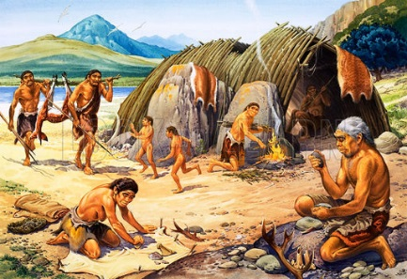  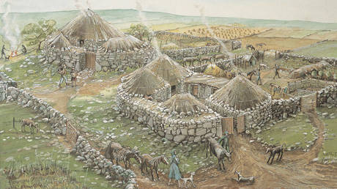 |  | Maths  Times tables  Place value to 4 digits  Addition, subtraction, multiplication, division methods.  Fractions and decimals.  2D and 3D shape – names, right angles, lines.  Measures – weighing (g/Kg), Capacity (ml / l) Telling the time.
Geography  Using maps and atlases, settlements, where we are in the world. | PE  Multi-skills, ball skills | RE  Religious rituals – rites of passage, baptisms and weddings. | History  Changes in Britain and lifestyle from stone age to ice age, inventions – comparison with our lives.
Design Technology  Design and make a model cave researching with non-fiction texts. | Music  Rhymes and raps – linked to literacy.  Instrument tuition. | PSHE  New beginnings, getting on and falling out. | Science  Rocks and fossils – identification and classification.  Electricity – making and testing circuits, switches, conductors and insulators.
ICT – Computing  Using the Internet – research skills, Microsoft Office skills and e-safety. | Art  Cave paintings, clay pots, natural jewellery, Stonehenge silhouettes. | Languages  Greetings, days of the week, colours, numbers to 20, animals, Christmas.

