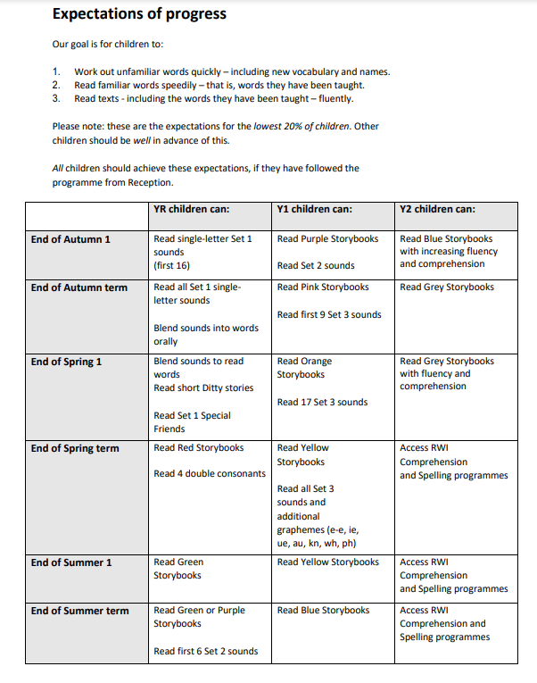

Completed RWI – taught from national curriculum

Completed RWI – taught from national curriculum